# Project Plan

## Team Chilli



**Name of the team:** TeamChilli

**Number of the Team Members:** 6

**Name and student number of team leader:**

* Andrea – 14007700

**Names and student numbers of team members:**

* Duran Moodley –
* Calvin Reed –
* Mthobisi Kunene –
* Warren Edy – 13014029
* Sachin –

## Introduction

The Baby house is an organization that takes in abandoned babies. Furthermore, they see to the needs and well-being of each child that is allocated to them. Our team aims to assist them in fulfilling their task by providing the Baby House La Lucia with a PHP an d android application that will allow them to improve their exposure to the outside community and improve their day to day functions.

There are several goals that we as team Chilli aim to achieve through the both the PHP and Android Applications:

1. Reduce Cost to Company

As the cost to company may be high The Baby House require the system to be developed in a manner that it can be cheap or inexpensive to run.

1. Reduce Processing Time and Improve Reporting

The current manual system takes a long time to process all information and there is no formal database that can generate reports that the company can use to their benefit. Hence, we aim to add additional features to their systems such as a database that allows the Baby House to generate the necessary reports they require

1. Increase Exposure

Create more exposure for the Baby House through modifying their website and creating an Android application that users can interact with.

The Risks of undergoing the project

1. NGO is non-responsive
2. Team member leaves/unable to perform duties
3. Running behind schedule
4. Scope Creep

Benefits for the customer

1. Computerized system
2. Reduced errors
3. More control of the company
4. Quick and Easy reports produced

## Milestones and Deliverables

## Work Breakdown Structure

|  |  |  |  |  |  |  |
| --- | --- | --- | --- | --- | --- | --- |
| **ID** | **Task Description** | **Duration** | **Start Date** | **End Date** | **Predecessors** | **Resources** |
| **A** | **1.0 Find NGO** | **1** | **01-Mar** | **05-Mar** |  | **All Team Members** |
| **B** | **2.0 Problem Statement** | **1** | **07-Mar** | **11-Mar** | **A** | **Duran** |
| **C** | **3.0 Project Plan** | **2** | **14-Mar** | **25-Mar** | **A,B** | **All Team Members** |
| *D* | *3.1 Introduction* | *1* | *14-Mar* | *18-Mar* | *A* | *Andrea* |
| *E* | *3.2 Milestones & Deliverables* | *1* | *14-Mar* | *18-Mar* | *D* | *Andrea* |
| *F* | *3.3 Work Break Down Structure* | *1* | *14-Mar* | *18-Mar* | *E* | *Duran* |
| *G* | *3.4 Project Schedules* | *1* | *14-Mar* | *18-Mar* | *F* | *Mtho* |
| *H* | *3.5 Risk Management* | *1* | *21-Mar* | *25-Mar* | *G* | *Sachin* |
| *I* | *3.6 Technical Feasibility Issues* | *1* | *21-Mar* | *25-Mar* | *H* | *Calvin* |
| *J* | *3.7 Economic Feasibility Issues* | *1* | *21-Mar* | *25-Mar* | *I* | *Warren* |
| **K** | **4.0 Requirements Anaylsis** | **2** | **28-Mar** | **08-Apr** | **C** | **All Team Members** |
| *L* | *4.1 Problem Domain* | *1* | *28-Mar* | *01-Apr* | *J* | *Duran* |
| *M* | *4.2 Solution Domain* | *1* | *28-Mar* | *01-Apr* | *L* | *Warren* |
| *N* | *4.3 Logical System Model* | *1* | *04-Apr* | *08-Apr* | *M* | *Calvin* |
| *O* | *4.4 Class Diagrams* | *1* | *04-Apr* | *08-Apr* | *N* | *Andrea* |
| **P** | **5.0 Design Document** | **2** | **11-Apr** | **22-Apr** | **K** | **All Team Members** |
| *Q* | *5.1 Logical Architectural Design* | *1* | 11-Apr | 15-Apr | *O* | *Sachin* |
| *R* | *5.2 User Interaction Design* | *1* | 11-Apr | 15-Apr | *Q* | *Warren* |
| *S* | *5.3 Database Design* | *1* | 18-Apr | 22-Apr | *R* | *Calvin* |
| *T* | *5.4 Report Design* | *1* | 18-Apr | 22-Apr | *T* | *Duran* |
| **U** | **6.0 Coding/Testing** | **8** | **03-May** | **25-Jun** | **P** | **All Team Members** |
| ***V*** | ***7.0 Project Handover*** | ***1*** | **27-Jun** | **01-Jul** | ***U*** | ***All Team Members*** |

## Project schedule

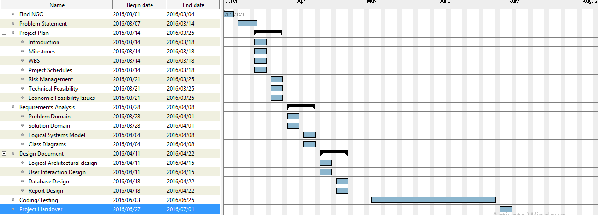

## Risk Management

|  |  |  |
| --- | --- | --- |
| Type of Risk: | Level of Impact: | Action to avoid Risk: |
| NGO is non-responsive | Very High | Not very easy to handle the situation if the NGO is not responding but the best would be to try and stick to the plan that they have approved and attempt to keep in contact with them if guidance is needed. |
| Team member leaves/unable to perform duties | High | In the case of this risk happening the best would be to make sure that work load is equal and far leading up to the event that way if a member does leave or falls ill as an example then splitting the work that the member has left behind will be more adaptable. |
| Power Failure | Very High | Although we have a lot of time for this project due to the fact that we are IT software developers, having electricity is very important so to help combat this would be to either make plans to either get a generator or work at a location that has power. There is nothing much you can do in this situation. |
| Loss of Data | Very High | This can be a huge problem as the loss of data can cause major setbacks and put on more pressure. To avoid this it would be wise to keep up to date backups of all information that way in the case of data loss we can always rely on having a backup. |
| Running behind schedule | Medium | Not finishing on time can cause a lot of pressure and cause the finished project to not be the ideal goal. Although it can cause a problem It isn’t the biggest concern when it comes to completing the task unless the work load gets out of hand and unable to finish. To not let this happen the best would be to stick to a schedule and make sure that all work is done in the designated time so that the end goal can be achieved with minimum stress or errors. |
| Team member isn’t pulling their weight | Medium | It’s not good to have one or even two members in the group not doing their tasks and ultimately pulling the rest of the group down. Although it is not a huge impact it can still hinder the group’s performance. For the group to all be equal in terms of distributed work it would be best to have each member given tasks that relate to their strengths. This will ensure that all members are doing something that they are good at meaning that the work will more likely get done and less chance of having one member slacking off. A routine check on everyone’s assigned work could also help. |

## Technical Feasibility

## Economic Feasibility

Economic Feasibility – is to analysis the project costs and revenues in an effort to determine whether or not it is logical and possible to complete as well as to determine the positive economic benefits to the organization that the proposed project system will provide to find if the identification and quantification of all the benefits expected.

|  |  |  |  |  |
| --- | --- | --- | --- | --- |
| **Task Identification** | **Team member(s) responsible** | **Time allocated per task per team member** | **Tariff per team member in Rand per hour** | **Cost per task(time*tariff)** |
| **Find NGO** | Andrea  Duran  Warren  Calvin  Mthobisi  Sachin | 48 Hours | R0 | R0 |
| **Conduct needs analysis** | Andrea  Duran  Warren  Calvin  Mthobisi  Sachin | 120 Hours | R70 | R8400 |
| **Draft software specifications** | Duran  Mthobisi | 72 Hours | R100 | R7200 |
| **Develop preliminary budget** | Andrea  Warren | 72 Hours | R40 | R2880 |
| **Analysis complete** | Duran  Warren  Calvin  Mthobisi  Andrea | 0 Hours | R0 | R0 |
| **Develop functional specifications** | Sachin  Calvin | 120 Hours | R90 | R10800 |
| **Develop prototype** | Warren  Duran | 96 Hours | R80 | R7680 |
| **Incorporate feedback** | Andrea  Duran  Warren  Calvin  Mthobisi  Sachin | 48 Hours | R0 | R0 |
| **Design complete** | Andrea  Mthobisi  Calvin | 24 Hours | R0 | R0 |
| **Develop code** | Warren  Duran  Andrea  Calvin  Mthobisi  Sachin | 240 Hours | R250 | R60000 |
| **Debug errors** | Duran  Warren | 100 Hours | R100 | R10000 |
| **Development complete** | Warren  Duran  Andrea  Calvin  Mthobisi  Sachin | 48 Hours | R0 | R0 |
| **Develop test plans** | Warren  Duran  Andrea  Calvin  Mthobisi  Sachin | 60 Hours | R35 | R2100 |
| **Develop integration test plans** | Sachin  Calvin | 100 Hours | R40 | R4000 |
| **Testing complete** | Mthobisi  Andrea | 24 Hours | R0 | R0 |
| **Develop deployment methodology** | Andrea  Duran  Warren  Calvin  Mthobisi  Sachin | 72 Hours | R75 | R5400 |
| **Deploy software** | Andrea  Duran  Warren  Calvin  Mthobisi  Sachin | 65 Hours | R150 | R9750 |
| **Deployment complete** | Andrea  Duran  Warren  Calvin  Mthobisi  Sachin | 24 Hours | R0 | R0 |
| **Project Handover** | Andrea  Duran  Warren  Calvin  Mthobisi  Sachin | 24 Hours | R0 | R0 |

## Team Members

**Team leader:**

**Andrea Mesaritis**

* Oversee entire project

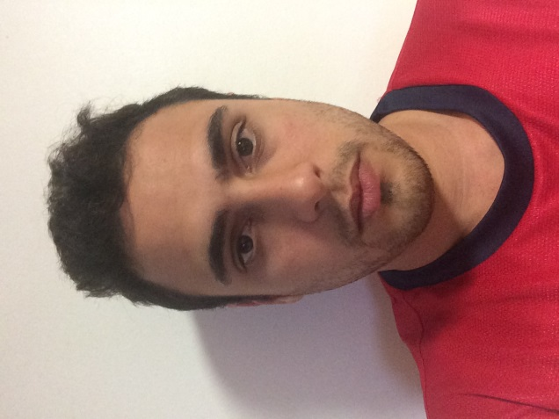

**Team members:**

1. **Duran Moodley**

* Head Coder

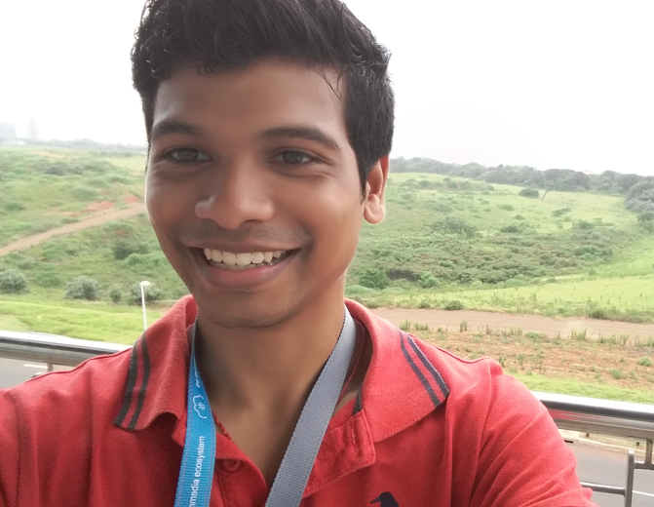

1. **Warren Edy**

* Head BLOW JOB GIVER :P



1. **Mthobisi Kunene**

* Database admin



1. **Calvin Reed**

* Database admin

1. **Sachin**

* Database admin

**CURRICULUM VITAE**

**Andrea Mesaritis**

**Curriculum vitae**

**Cell:** 0731363391

**Email:** [rugreekboy@gmail.com](mailto:rugreekboy@gmail.com)

**Address:** 134 Ocean view Road

Athlone Park

Durban

4040

**Personal Information**

**Date of Birth:**  16 March 1991

**Identity Number:** 9103165100085

**Nationality:** South African

**Home Language:** English

**Interests / Hobbies:** Equities, Programming, Retail, Guitar, Reading

**Personal Profile**

Outgoing friendly personality, High energy levels, Passionate, Ambitious, Diligent and Self-motivated

**Educational Background**

**Tertiary Education**

**Institution:** Varsity College – Durban North

**Period:**  2014 - Current

**Year of study:** Second year

**Diploma:** Software Development

**Major Subjects:** Programming, Database, System Analysis and Design

**Tertiary Education**

**Institution:** Rhodes University

**Period:** 2009 - 2012

**Year of study:** Complete

**BCom Honours:** Economics –Banking and Finance route

**Major Subjects:**

**Secondary Education**

**Institution:** Matriculated – Hilton College, Hilton

**Period:**  2004 - 2008

**Subjects:** Mathematics, English, Afrikaans, Science, Accounting, Art, Life Orientation

**Achievements**

**2011:** - Greek Society Treasurer

- Obtained Bachelor of Commerce Degree from *Rhodes University*

**2012:** - Economics 1 Tutor

- Accepted into Bachelor of Commerce Honours in Economics at *Rhodes University*

- Obtained 70% average for Bachelor of Commerce Honours in Economics at *Rhodes University* in 2012

**2013:** - Pastel Accounting Certification

- Pastel Payroll Certification

- *Spar* Management Induction Programme Certificate

- *Spar* Young Managers Certificate

- *Spar* Sigma Basic and Advanced Certificate

**2014:** - Distinction in Software Development

**2015:** - Academic Bursary awarded for Software Development

**Skills**

**Computer Skills:** MS Word, Excel, PowerPoint, Access, Programming in Java, C#

**Skills:** Interpersonal, Management, Leadership, Pastel Accounting, Pastel Payroll, SIGMA, HTML, CSS, Microsoft Access, SQL

**References**

**Name:**  Joyce Sunker

**Position:** Manager at Winkle Superspar

**Contact:** 031 91666 55

**Name:**  Rajesh Chanderman

**Position:** Programming Lecturer

**Company:** Varsity College

**Contact:** 078 6683531

**Duran Moodley**

|  |  |  |  |
| --- | --- | --- | --- |
| **PERSONAL DETAILS** | | **CONTACT DETAILS** | |
| **ID Number** | **9504125163081** | **Cell phone Number** | **071 355 8911** |
| **Nationality** | **South African** | **Home Number** | **031 303 8517** |
| **Gender** | **Male** | **Email address** | **duranmoodley97@gmail.com** |
| **License** | **Code 8** | **Residential Area** | **Morningside** |

**SUMMARY**

I see myself as being a hard working individual who will always give the best in any task that I encounter. I am confident communicator. Furthermore, I interact with all types of people on a regular basis. I have been faced with many challenges throughout my schooling and Varsity life but I have always fought through those challenges with determination and commitment.

**EDUCATION ACQUIRED AND SKILLS**

**Tertiary**

Institution:Varsity College   
Qualification: IIE Diploma in Software Development

Duration: 2014 - 2016

**Secondary**

Institution:Clifton College

Highest grade: Matriculation

Year Matric: 2013

Subjects: Maths core, Drama, IT, Accounting, English, Life Orientation, Afrikaans

**Computer Skills**:

* Programming Languages
  + Java
  + C#
  + php
  + html
  + SQL
* Programs/IDE
  + All Microsoft Office applications
  + Net beans
  + Visual Studio
  + Android Studio
  + Oracle
  + Sql Server
  + Executed Site Migrations using :
    - Web host Manager
    - Console H
    - C panel
* Other Skills
  + Tutored/lectured Varsity college students in IT programming

**ACHIEVEMENTS**

* Top Student in IT Software Development at Varsity College(2013)
* Lead Actor in a National Production (Mamma Mia Musical 2)
* Finalist in a talent competition (African Mela)
* The Most hard working student 2013 (award)
* School Prefect
* Full colours for Drama
* Best Senior performer for 2013 at Clifton College (drama)
* Head boy at Addington Primary 2008

**WORK EXPERIENCE**

**Company Name: Xcallibre**

Position Held: Android Developer

Period of Employment: 1 March 2016 - Ongoing

Key Duties: Coding the android application

**Company Name: Immedia**

Position Held: Summer Schooler

Period of Employment: 1 – 5 February 2016

Key Duties: Focused on Android Development

Used an application program interface (API)

Connected to SQLite database with Android

Developed an interactive Android game

Gained insight into a post-PC solutions company

**Company Name: Addington Primary School**

Position Held: Software Developer

Period of Employment: January 2016 - Ongoing

Key Duties Design Interfaces

Create database

Code ,test and debug the program

**Company Name: Varsity College (Durban North)**

Position Held: Registration Assistant

Period of Employment: December 2014 - February 2015, December 2015

Key Duties: Made Student Cards

Entered Student Fingerprints into the biometric system

Helped Students with Unisa and UFS online registration

Registered Students to Varsity College

Interacted with parents and students as well as toured them around Varsity College

**Company Name: Brilliant Web**

Position Held: Intern

Period of Employment: January 2015 – April 2015, December 2015

Key Duties: Moving websites to different serves

Updating client passwords

Mail Sync client email

Remove client emails from servers

**Company Name: Roshan Singh Productions**

Position Held: Lead Actor and Dancer

Period of Employment: April 2014 - December 2014

Key Duties Had interviews done by Dstv

Lead Actor in a Musical

Danced at big functions held at Sibiya, ICC, Phoneix fair and Durban City Hall

Performed in charity events (Nelson Mandela 67 minutes festival)

**REFERENCES**

**Name of Reference**: Brendon Hatcher

Name of Company: Brilliant Web

Job title: Intern

Contact Details: 082 434 5343

**Name of Reference**: Sugendri Reddy

Name of Company: Addington Primary School

Job title: Software Developer

Contact Details: 076 480 7226

**Name of Reference**: Abby Bryson/Rajesh Chanderman

Name of Company: Varsity College

Job title: Registration Assistant

Contact Details: 031 573 2038

**Name of Reference**: Roshan Singh

Name of Company: Roshan Singh Productions

Job Title: Actor/Dancer

Contact Details: 073 372 5956

**Warren Edy**

**Curriculum Vitae**

**Cell:** 0620072925

**Email:** 13014029@vcconnect.co.za

**Address:** 10 Gelderland Road

Umgeni Park

Durban

4051

**Personal Information**

**Date of Birth:**  12 April 1995

**Identity Number:** 9504125020083

**Nationality:**  South African

**Home Language:** English

**Interests / Hobbies:**  Playing sport, gaming, staying healthy and fit

**Personal Profile**

I am a self-motivated and disciplined individual, always seeking the best possible opportunities and believe that I would be an assist to any business or organization.

**Educational Background**

**Tertiary Education**

**Institution:** Varsity College – Durban North

**Period:**  2014 - Current

**Year of study:**  Second year

**Diploma:** Software Development

**Major Subjects:** Programming, Database, System Analysis and Design

**Secondary Education**

**Institution:** Matriculated –Northwood Boys High School, Durban

**Period:**  2009 - 2013

**Subjects:** English, Afrikaans, Accounting, Geography, Life Science, Mathematics, Life Orientation

**Achievements**

**2014:**  4 Distinctions in first year of tertiary studies

**2009:** Obtained my black belt in karate.

**Skills**

**Computer Skills:** MS Word, Excel, PowerPoint, Access, Programming in Java

**Skills:**  Interpersonal, Team Motivator

**References**

**Name:**  Mr Jaffar

**Position:** Virginia Preparatory School

**Contact:** 0834567321

**Mthobisi Kunene**

**PROFESSIONAL PROFILE**

I am a young, hardworking individual who has very strong communication skills. I am both people and detail orientated and I am eager to learn new skills which enable me to better my abilities

**PERSONAL DETAILS**

Surname: Kunene

First Names: Mthobisi Lungelo

Identity Number: 9504035143082

Nationality: South African

Gender: Male

Residential Area: Durban North

Home Language: Zulu

Other Languages: English, Afrikaans

Email Address: mkunene099@gmail.com

Cell Number: 071 458 1739

Drivers’ License: Yes

Own transport Yes

**SECONDARY EDUCATION**

Secondary School: Vryheid High School

Qualification: National Senior Certificate

Subjects Passed: English Home Language

Zulu 1st Additional Language

Life Orientation

Mathematical Literacy

Computer Applications Technology

Geography

Life Sciences

Year Obtained: 2013

**TERTIARY EDUCATION**

Institution: Varsity College Durban North

Course: Diploma in I.T. Software Development

Current Level of Studies: 3rd Year

Major Subjects: Programming

Programming Logic and Design

Analytical Technique

Business Communications

End User Computing

Database Applications

System Design and Analysis

Project Management

Web Development

Advanced Database programming

Information Security